The changes to the “Hours/Units” entry page in CurricUNET were brought on by new Title 5 regulations that require the course outline of record indicate the maximum hours for a course. Therefore we made some changes to CurricUNET to accommodate this requirement and hopefully make it easier to enter course information.

Below are instructions for the following types of courses; Lecture Only, Lab Only, Lecture/Lab Combination, Variable Units, Other Hours, Variable Units and Other Hours, and ADJU/FIPT. If you need assistance please call the CurricUNET Help Desk x6502. (M-F 8:00am-5:00pm)

Lecture Only Course
Once you’ve logged in and selected the course you want to modify or once you’ve created a new course, click on the “Hours/Units” page from the Course Checklist.
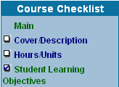

If the course has variable units then click “Yes” and see instructions for “Variable Unit Course”. If not then leave as “No”.

Enter the Lecture Unit value for the course.

PLEASE NOTE: For a lecture only course the Lab Units and Other Units fields will remain blank. (If the course is not a lecture course see instructions for other types of courses).
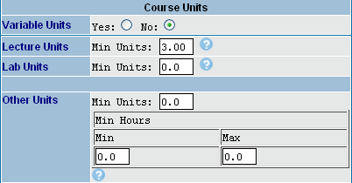

If the course is repeatable enter the number of times the course can be taken; otherwise enter “1”.

Add additional information pertaining to the hour/units in the “Additional Information” field if desired.

Select or verify the “Field Trips” designation for the course.

Select or verify the “Grade Option” designation for the course.

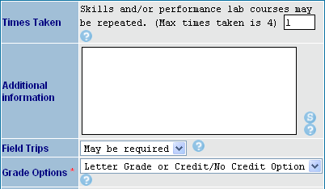

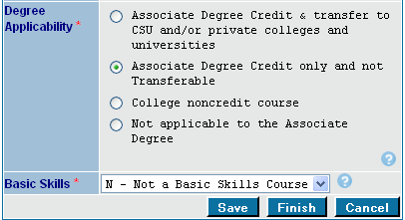
Select or verify the “Degree Applicability” designation for the course.

Select or verify the “Basic Skills” designation for the course.

Click “Finish”

PLEASE NOTE: Most courses are not basic skills.

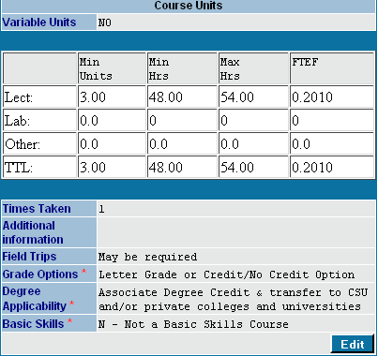
After clicking “Finish” the total hours for the course are displayed.

A summary of what has been selected on the page is displayed.

To make changes to the data entry fields click on “Edit” to access the fields.

Lab Only Course
Once you’ve logged in and selected the course you want to modify or once you’ve created a new course, click on the “Hours/Units” page from the Course Checklist.

If the course has variable units then click “Yes” and see instructions for “Variable Unit Course”. If not then leave as “No”.

Enter the Lab Unit value for the course.

PLEASE NOTE: For a lab only course the Lecture Units and Other Units fields will remain blank. (If the course is not a lab course see instructions for other types of courses).

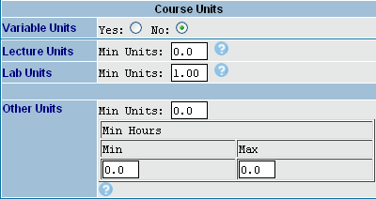

If the course is repeatable enter the number of times the course can be taken; otherwise enter “1”.

If you want to add additional information pertaining to the hour/units enter in the “Additional Information” field.

Select or verify the “Field Trips” designation for the course.

Select or verify the “Grade Option” designation for the course.

Select or verify the “Degree Applicability” designation for the course.

Select or verify the “Basic Skills” designation for the course.

Click “Finish”

PLEASE NOTE: Most courses are not basic skills.

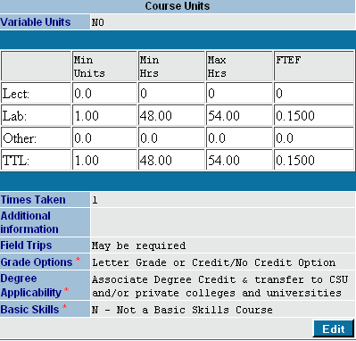
After clicking “Finish” the total hours for the course are displayed.

A summary of what has been selected on the page is displayed.

To make changes to the data entry fields click on “Edit” to access the fields.

Lecture/Lab Combination Course

Once you’ve logged in and selected the course you want to modify or once you’ve created a new course, click on the “Hours/Units” page from the Course Checklist.

If the course has variable units then click “Yes” and see instructions for “Variable Unit Course”. If not then leave as “No”.

Enter the Lecture Unit value and Lab Unit value for the course. (The total Unit value will display once you click finish).

PLEASE NOTE: For a lecture/lab combo course the Other Units fields will remain blank. (If the course is not a lecture/lab combo course see instructions for other types of courses).
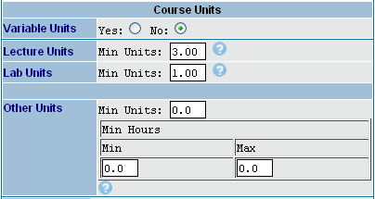

If the course is repeatable enter the number of times the course can be taken; otherwise enter “1”.

If you want to add additional information pertaining to the hour/units enter in the “Additional Information” field.

Select or verify the “Field Trips” designation for the course.

Select or verify the “Grade Option” designation for the course.

Select or verify the “Degree Applicability” designation for the course.

Select or verify the “Basic Skills” designation for the course.

Click “Finish”

PLEASE NOTE: Most courses are not basic skills.

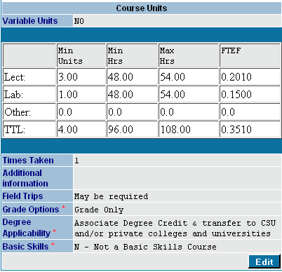
After clicking “Finish” the total hours for the course are displayed.

A summary of what has been selected on the page is displayed.

To make changes to the data entry fields click on “Edit” to access the fields.

Variable Unit Course

Once you’ve logged in and selected the course you want to modify or once you’ve created a new course, click on the “Hours/Units” page from the Course Checklist.

Since the course has variable units click “Yes” which gives a range to enter the unit values.

Enter the Lecture Unit values or Lab Unit values for the course. (The total Unit values will display once you click finish).

PLEASE NOTE: The Other Units fields will remain blank. (If the course is not a variable unit course see instructions for other types of courses).

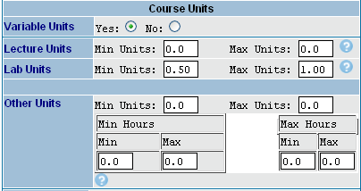

If the course is repeatable enter the number of times the course can be taken; otherwise enter “1”.

If you want to add additional information pertaining to the hour/units enter in the “Additional Information” field.

Select or verify the “Field Trips” designation for the course.

Select or verify the “Grade Option” designation for the course.

Select or verify the “Degree Applicability” designation for the course.

Select or verify the “Basic Skills” designation for the course.

Click “Finish”

PLEASE NOTE: Most courses are not basic skills.

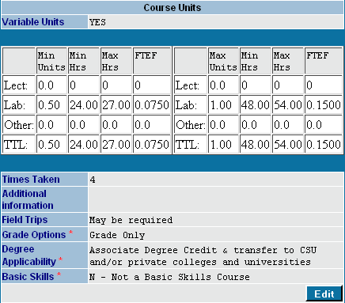
After clicking “Finish” the range of total hours for Minimum Unit value and the Maximum Unit value of the course are displayed.

PLEASE NOTE: Only the minimum unit and maximum unit values are displayed.

A summary of what has been selected on the page is displayed.

To make changes to the data entry fields click on “Edit” to access the fields.

Other Hours Course
Once you’ve logged in and selected the course you want to modify or once you’ve created a new course, click on the “Hours/Units” page from the Course Checklist.

If the course has variable units click “Yes” and see instructions for “Variable Unit and Other Hours Course”. If not then leave as “No”.

Enter the Other Unit value for the course. Also add the total number of hours required for the course in the Min/Max fields.

PLEASE NOTE: The Lecture and Lab Units fields will remain blank. (If the course is not an other hours course see instructions for other types of courses).

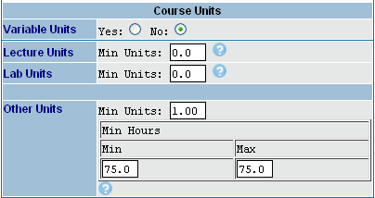

If the course is repeatable enter the number of times the course can be taken; otherwise enter “1”.

If you want to add additional information pertaining to the hour/units enter in the “Additional Information” field.

Select or verify the “Field Trips” designation for the course.

Select or verify the “Grade Option” designation for the course.

Select or verify the “Degree Applicability” designation for the course.

Select or verify the “Basic Skills” designation for the course.

Click “Finish”

PLEASE NOTE: Most courses are not basic skills.

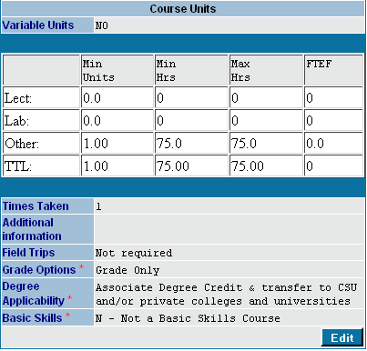
After clicking “Finish” the range of total hours and units will reflect your entry.

PLEASE NOTE: No FTEF is calculated for Other Hours courses.

A summary of what has been selected on the page is displayed.

To make changes to the data entry fields click on “Edit” to access the fields.

Variable Unit and Other Hours Course
Once you’ve logged in and selected the course you want to modify or once you’ve created a new course, click on the “Hours/Units” page from the Course Checklist.
Since the course has variable units click “Yes” which will give you a range to enter min and max unit values.

Enter the Min and Max Other Unit values for the course. Add the corresponding min/max unit values for the min unit value and the max unit value.

PLEASE NOTE: The Lecture and Lab Units fields will remain blank. (If the course is not an other hours course see instructions for other types of courses).

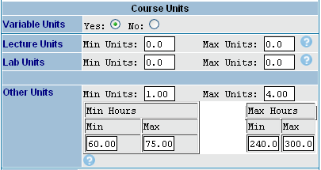

If the course is repeatable enter the number of times the course can be taken; otherwise enter “1”.

If you want to add additional information pertaining to the hour/units enter in the “Additional Information” field.

Select or verify the “Field Trips” designation for the course.

Select or verify the “Grade Option” designation for the course.

Select or verify the “Degree Applicability” designation for the course.

Select or verify the “Basic Skills” designation for the course.

Click “Finish”

PLEASE NOTE: Most courses are not basic skills.

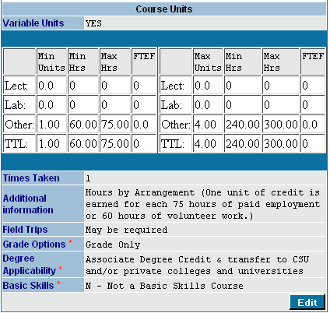
After clicking “Finish” the range of total hours and units will reflect your entry.

PLEASE NOTE: No FTEF is calculated for Other Hours courses.

A summary of what has been selected on the page is displayed.

To make changes to the data entry fields click on “Edit” to access the fields.

Administration of Justice and Fire Protection Technology Courses

The data entry for ADJU and FIPT courses is somewhat different from other courses because the hour/unit ratio is not always standard. Therefore you are able to enter the lecture and/or lab unit values and the TOTAL lecture and/or lab hours for these courses. If the course is a standard lecture and/or lab course you’ll still have to manually enter the total hours for the course. Below is a chart to help determine the hours.

Once you’ve logged in and selected the course you want to modify or once you’ve created a new course, click on the “Hours/Units” page from the Course Checklist.

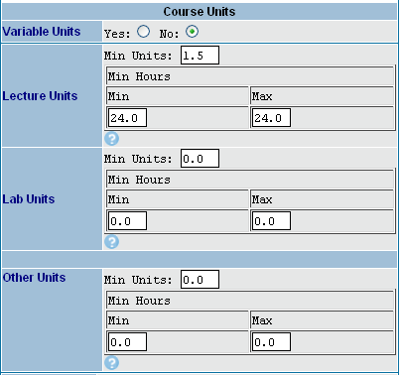
If the course has variable units click “Yes” which will give you a range to enter min and max unit values. If not leave as “No”.

Enter the Lecture and/or Lab Unit values for the course. Add the corresponding min/max hours for the course. (If a variable unit course you’ll enter the min/max units and the min/max hours)

PLEASE NOTE: The Other Units fields will remain blank. (If the course is not ADJU or FIPT course see instructions for other types of courses).

If the course is repeatable enter the number of times the course can be taken; otherwise enter “1”.

Add additional information pertaining to the hour/units in the “Additional Information” field (For example, when additional lecture hours are in lieu of outside assignments).

Select or verify the “Field Trips” designation for the course.

Select or verify the “Grade Option” designation for the course.

Select or verify the “Degree Applicability” designation for the course.

Select or verify the “Basic Skills” designation for the course.

Click “Finish”

PLEASE NOTE: Most courses are not basic skills.

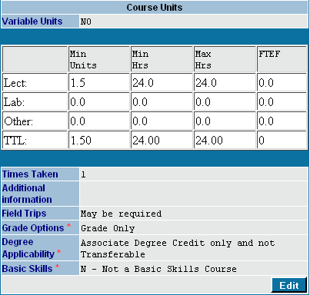
After clicking “Finish” the range of total hours and units will reflect your entry.

PLEASE NOTE: No FTEF is calculated for ADJU/FIPT courses. The FTEF will be calculated manually by Instructional Services.

A summary of what has been selected on the page is displayed.

To make changes to the data entry fields click on “Edit” to access the fields.

Standard Units/Hours Chart (Min-Max)
Unit Value | Lecture Hours | Lab Hours
0.5 | 8-9 | 24-27
1.0 | 16-18 | 48-54
1.5 | 24-27 | 72-81
2.0 | 32-36 | 96-108
2.5 | 40-45 | 120-135
3.0 | 48-54 | 144-162
3.5 | 56-63 | 168-189
4.0 | 64-72 | 192-216
4.5 | 72-81 | 216-243
5.0 | 80-90 | 240-270

